DM1800 Brush Head Assembly

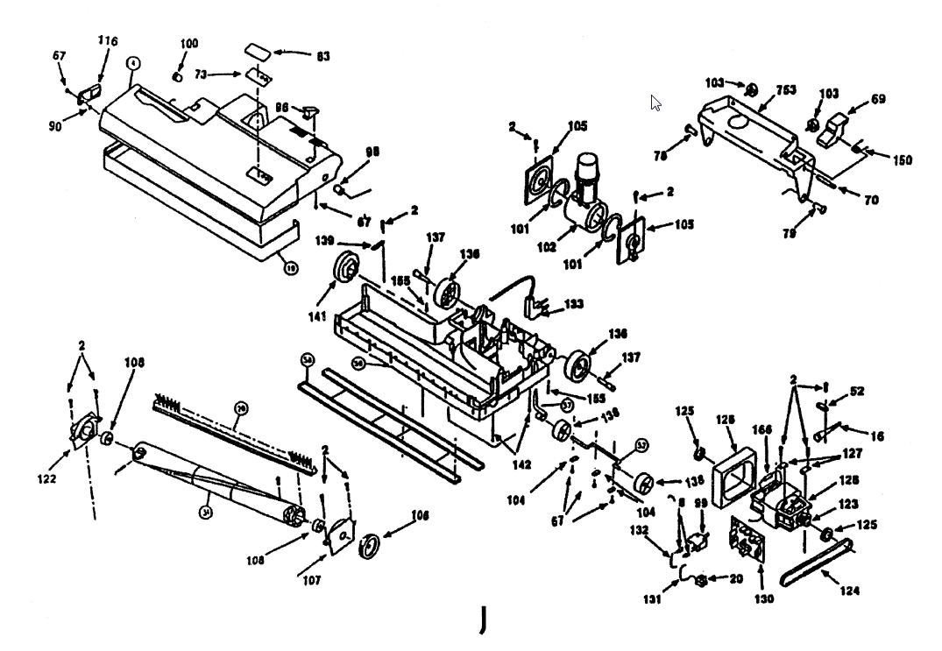
32
4
37
26
31
18

